Woodstock High School Update

For the majority, students will attend school based on their last name. We have split the classes as follows:
Gray – students with the last name A-L
Garnet – students with the last name M-Z

Some students will fall into the opposite category as we are limiting class sizes. If you are in this category, you will be notified by a phone call from administration or guidance. Most of these calls have been made.

Students will attend school on every other day basis. While they are at home, work will be assigned and expected to be completed. This may be done in various forms and will be teacher directed.

If students are being dropped off, please use the student parking lot or drop them off at another location such as the AYR Motor Center and in good weather have them walk down to the school. We ask that the staff parking lot is not used as it interferes with busing and is extremely dangerous. An exception to this being used as a drop off would be students who require handicap parking spots.

Week of September 8-11
Tuesday September 8th – all grade 9 students. This will be a day of orientation and classes. When students come into the building, there will be staff and leaderships students there to help direct them to the appropriate locations. They will receive their schedule that morning.
Wednesday September 9th – Garnet grades 10-12. M-Z Schedules will be available at this time.
Thursday September 10 – Gray – all grades 9-12. A-LSchedules will be available at this time.
Friday September 11 – Garnet – all grades. M-Z

Week of 14- 18
Monday September 14 – Gray
Tuesday September 15 – Garnet
Wednesday September 16-Gray
Thursday September 17 -Garnet
Friday September 18 -Gray
We ask students to arrive as close to the start of the day without being late when possible. This will help reduce contact.
Masks must be worn during all transitional time and when they are in peer groupings inside the building during non instructional time such as lunch time , before and after school. Of course, this does not include while they are eating; however, they must be seated 6 feet from other people.
During Covid, we will be going directly to our first teaching class which is considered period 2 as homeroom is period 1.

Bell Schedule
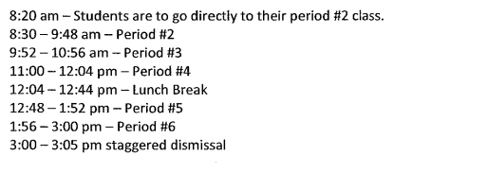
More information will be coming in the following week. Please keep checking our website and Instagram/facebook.

